**Project Design Phase-II**

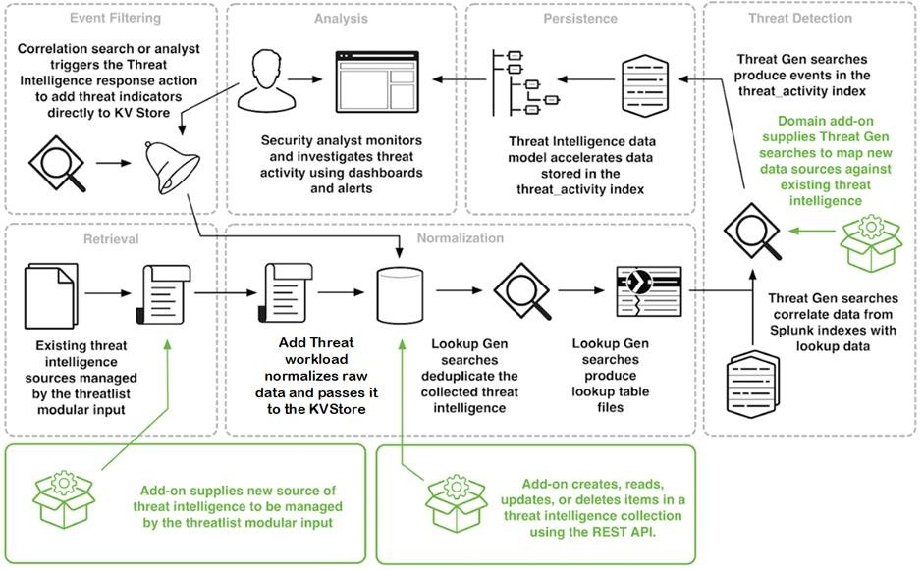**Technology Stack (Architecture & Stack)**

|  |  |
| --- | --- |
| Project Name | AI-based Threat Intelligence Platform |

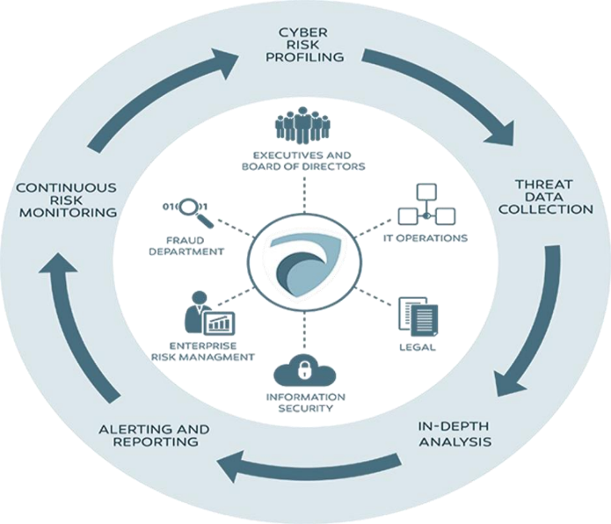

Table 1: Components & Technologies:

|  |  |  |  |
| --- | --- | --- | --- |
| S.No | Component | Description | Technology |
| 1 | Threat Detection | Real-time identification of potential threats | Machine Learning, AI |
| 2 | User Interface | Intuitive and user-friendly platform | Web-based, UI/UX Design |
| 3 | Data Integration | Seamless incorporation of diverse data sources| | API Integration |
| 4 | Automated Response | Swift initiation of predefined security protocols | Scripting, Automation |
| 5 | Predictive Analytics | Forecasting potential future threats | Data Analysis, Machine Learning |
| 6 | Reporting and Alerts | Customizable reporting and alerting mechanisms | Data Visualization, Alerts |
| 7 | Compliance Management | Adherence to regulatory standards | Compliance Tools, Monitoring |
| 8 | Scalability | Adaptable architecture for diverse infrastructures | Cloud Computing, Scalable Technologies |
| 9 | Continuous Learning | Feedback loop for continuous improvement | Neural Networks, Data Analysis |

Table 2: Application Characteristics:

|  |  |  |  |
| --- | --- | --- | --- |
| S.No | Characteristics | Description | Technology |
| 1 | Real-Time Monitoring | Continuous monitoring for immediate threat detection | AI Algorithms, Data Streaming |
| 2 | Predictive Analysis | Forecasting potential future threats | Machine Learning, Data Analytics |
| 3 | Seamless Integration | Smooth integration with diverse security systems | API Integration, Compatibility Solutions |
| 4 | User-Friendly Interface | Intuitive and easy-to-navigate platform | UI/UX Design, Web Technologies |
| 5 | Automated Response | Swift initiation of predefined security protocols | Scripting, Automation Tools |
| 6 | Customizable Reporting | Tailored reporting and alerting mechanisms | Data Visualization Tools, Alert Systems |